Lower Suwannee NWR Hunting Regulations 2025-2026
2025 – 2026 Lower Suwannee National Wildlife Refuge Quota Hunt Permit Process
The Lower Suwannee National Wildlife Refuge’s (Refuge) Quota Hunt Permits will be issued by the Florida Fish and Wildlife Commission’s “Go Outdoors Florida” website, on a first-come, first-served basis at 10:00 AM on the “Release Date” for five grouped hunts.
Once a permit is purchased it is good for the entire year of 11 Refuge hunts so there is no need to purchase a separate Refuge Hunt Permit for each hunt.
Hunters must be legal with the State of Florida, carry a license and relevant permits or be exempt, buy/carry a current Refuge Quota Hunt Permit, and have a current Refuge Hunt Regulations Brochure on their person, hard copy or electronic; and know the material in it.
Note - You must:
- Buy a Florida license or be exempt.
- Buy a Go Outdoors Florida Refuge Quota Hunt Permit.
- Each hunter is responsible for everything in this regulations brochure and carry one on their person.
- Hunts are contingent upon law enforcement coverage.
Refuge Quota Permits are available for purchase 30 days in advance (at 10AM first-come-first-served) of a scheduled hunt through the Florida Fish and Wildlife Conservation Commission (FWC) licensing website https:// gooutdoorsflorida.com/; https://myfwc.com/ license/limited- entry/. Get ‘em while they last!
The Annual Hunter Working Group meeting will be held at Refuge Headquarters on the third Thursday in April, at 2 pm. Contact the Refuge Manager (850.527.8535) to attend. Hunters can voluntarily provide their contact info for periodic updates at: https://www.friendsofrefuges. org/hunter-signup.html.
General Information
https://www.friendsofrefuges.org Lower Suwannee National Wildlife Refuge’s (LSNWR) 53,000 acres along the Suwannee River in Dixie and Levy Counties has over 200 miles of roads and trails that provide vehicle, foot, or bicycle access to many habitat types open to a variety of public hunting and recreation opportunities.
All general Refuge and state regulations, mapped restrictions, and mapped designations apply unless specifically addressed in this leaflet. Please note that forest management/maintenance activities, including prescribed burns, mowing, and logging operations may occur at any time during the year. The Refuge reserves the right to temporarily close roads or land areas for any management reason without prior notification. Share the woods, the Refuge is open to other public uses during hunt seasons.
The following regulations supplement Florida state hunting regulations and general regulations governing hunting on LSNWR set forth in Title 50, Code of Federal Regulations.
Permit Requirements
Every adult hunter (16 and older) must purchase and possess a LSNWR Quota Hunting Permit and a State of Florida Hunting License, unless otherwise exempt. A current LSNWR Hunt Regulations Brochure must be in possession in hard copy or electronically by all hunters aged 16 and older.
Youth hunters 15 and under are not required to possess a LSNWR Quota Hunt Permit. Unless otherwise exempt, hunters are required to have appropriate archery, muzzleloader, deer, and turkey stamps/permits. Unless exempt, waterfowl hunters are required to have appropriate State and Federal waterfowl stamps.
Successful hunters are required to report their bag to the FWC’s Harvest Reporting System within 24 hours of harvest. The FWC’s Florida Hunting Regulations handbook is available for deer harvest reporting; instructions at https://myfwc.com/media/21998/ deer-harvest-log.pdf. These reports allow us to better determine population health, numbers, and stability.
NOTE: Absence of accurate and timely bag reports will result in shortened seasons or cancelled hunts.
General Hunting Regulations
Persons possessing, transporting, or carrying firearms on National Wildlife Refuges must comply with all provisions of State and local law. Persons may only use (discharge) firearms in accordance with Refuge regulations.
All motorized land vehicles must be state-legal and are restricted to designated primary roads shown on the map. Vehicles must park so they do not block roads or gates. If gates are closed you may walk or bike in. All-terrain vehicle use (ATV/UTV, etc.) is prohibited.
Hunters (including persons accompanying hunters) must comply with State of Florida fluorescent orange safety clothes requirements during all Refuge deer hunts except archery.
In addition to State of Florida hunter education requirements, hunters under the age of 16 must be supervised by an adult 18 years of age or older and must remain within sight and normal voice contact of the youth hunter. During Waterfowl, Small Game, and Family Hunts, one adult may supervise no more than two youth hunters. During Archery, Muzzleloader, General Gun, Hog, and Spring Turkey Hunts, the adult may supervise only one youth hunter.
Dogs may only be used as an aid to take raccoons during the raccoon night-hunting season and for waterfowl season. Otherwise, dogs must always be leashed under the direct control of the handler.
Hunters using the Refuge are subject to inspection of licenses, permits, hunting equipment, bag limits, vehicles and their contents, during compliance checks by a law enforcement officer
Closed gates will be open one week before Archery Season and will be closed at the end of the fall hunts and open before the January hunts, then closed after these hunts until the next Archery Season.
Temporary tree stands may be left on the Refuge starting one week before Archery Season and must be removed one day after the end of General Gun Season. Temporary tree stands may be left on the Refuge starting one week before Wild Hog Season and must be removed one day after the end of that season. Gates will then be closed. All tree stands left on the refuge must display the hunter’s hunting license number legibly written on or attached to the stand. Tree stands not in compliance may be confiscated and disposed of according to Federal Regulation. The Refuge is not responsible for damage to or theft of stands.
Flagging, reflective markers, paint, litter, or pins may NOT be used for marking in any manner on refuge property. Clothes-type pins or removable clips with reflective or colored markings can be used for the temporary marking of vegetation to identify a route of travel to or from a tree stand. These pins must be removed by the end of each scheduled hunt season. Each clothes-type pin or clip must contain the hunter’s hunting license number.
Hunters may enter no earlier than 1 and 1/2 hours before legal sunrise and must be out of the woods no later than 1 and 1/2 hours after legal sunset.
Special use permits are considered for people with disabilities; contact John_Stark@fws.gov. Due to a reduction in staff, the issuance of permits may not be possible.
Bows/crossbows use is legal during all hunts.
Prohibited Actions
- All commercial activities including guiding or participating in a guided hunt are prohibited.
- Target practice or any non-hunting discharge of a weapon is prohibited.
- Use of organized drives for hunting to take or attempting to take game is prohibited.
- Marking any tree, or other Refuge feature with carving, flagging, litter, paint, or blaze is prohibited.
- Possession, intoxication, or use of alcoholic beverages is prohibited while on the Refuge.
- Camping, fires, littering, and horses are prohibited.
- Collecting or harvesting any articles of antiquity, plants, animals or parts thereof is prohibited unless specifically authorized by a Refuge permit.
- Cutting trees, removing wood or other plant matter from the Refuge is prohibited.
- Hunting or shooting from within 150-feet of Refuge roads, open to public vehicle travel, is prohibited.
- Hunting from a tree in which a metal object has been inserted is prohibited.
- Field dressing or discarding an animal carcass or parts thereof within 1000 feet of any developed public recreation area, check station, gate, or within 100 feet of a road or trail, open to the public, is prohibited. Dumping of game carcasses is prohibited. Remember, no one wants to see this.
- Construction of permanent blinds or stands is prohibited.
- The placing of or hunting with the aid of ingestible attractant (feed, bait, salt, oil) is prohibited.
- Driving any vehicle or boat on marshes or emergent aquatic vegetation, or through the forest off of public driving roads is prohibited.
Specific Hunt Regulations
HOGS: NO SIZE OR BAG LIMIT FOR HOGS
Take ‘em all; take hogs during any hunt season except Spring Turkey and Waterfowl.
In designated Archery Only Areas (see map), only bows and crossbows allowed. Coyote may be taken during Archery, Muzzleloader, General Gun, and Family Hunt seasons.
​Legal Deer
Legal deer must have an antler with at least 2 points, 1 inch or more in length. Hunters 16 years of age and older may not take, during any season or by any method, an antlered deer not meeting this criterion. Youth 15-years-old and younger may harvest 1 deer annually not meeting antler criteria but having at least 1 antler 5 inches or more in length. Antlerless deer are deer that do not have antlers or have antlers less than 5 inches in length. It is illegal to take spotted fawns.
Waterfowl Permit
Waterfowl Permit release date is 14 August 2025, 300 permits total for waterfowl and archery.
State waterfowl season; ducks and coots only. Decoys and boats must be removed daily. Hunters must use and possess only shells containing non-toxic shot; Migratory Bird Hunting Regulations
Archery: September 13 - October 12, 2025.
Permit release date is 14 August 2025, 300 permits total for waterfowl and archery.
Archery and crossbow equipment allowed. Legal to take antlered or antlerless deer, wild hog, coyote, gray squirrel, rabbit, opossum, and raccoon. Archery hunters can hunt all refuge lands open to hunting and during any season. Archery Only Areas (see map) are open during all hunts with approved archery equipment only.
Muzzleloader: October 18 – 26, 2025.
Permit release date is 18 September 2025, 150 permits total.
Muzzleloader firearms and archery equipment only; legal to take antlered deer.
General Gun (GG)
GG No. 1: November 1 - 9, 2025.
GG permit release date is 2 October 2025, 200 permits total for all three GG.
Legal to take antlered deer.
Thanksgiving GG - Family / Senior Hunt / Disabled Veterans: November 22 - 24, 2025.
GG permit release date is 2 October 2025, 200 permits total for all three GG.
Up to 2 youth hunters (less than 16 years old) may hunt but must be supervised by an adult 18 years of age or older. Supervising adults may also hunt but must accompany at least 1 youth hunter. Senior adult hunters (65 years of age or over) and Disabled Veterans may also hunt and may be accompanied by 1 companion of any age that may also hunt. Allowed: legal deer, antlerless deer, and hogs. The FWC’s Antlerless Deer Season (Deer Management Unit C3) bag limits apply during this hunt.
GG No. 2: November 25 - 30, 2025.
GG permit release date is 2 October 2025, 200 permits total for all three GG.
Legal to take antlered deer and hogs (no antlers on hogs...)
Wild Hog Hunt: (take ‘em all!) January 31 – February 15, 2026.
Permit release date is 25 December 2025, 200 permits total for Small Game, Wild Hog, and Raccoon/Opossum.
Legal to take hogs only (no size or bag limit).
Small Game: January 31 – February 15, 2026
Permit release date is 25 December 2025, 200 permits total for Small Game, Wild Hog, and Raccoon/Opossum.
Legal to take gray squirrel, opossum, rabbit, and raccoon.
Raccoon/Opossum: January 31 – February 15, 2026
Permit release date is 25 December 2025, 200 permits total for Small Game, Wild Hog, and Raccoon/Opossum.
Night dog hunting only, from sunset until midnight. State regulations, weapons, and ammunition requirements apply. Limit two raccoons or opossums combined per night.
Youth Spring Gobbler Hunt: March 14 - 15, 2026
Permit release date is 12 February 2026, 200 permits total for Youth and Spring Turkey.
Only youth under 16 years of age may hunt and must be under the supervision and in the presence of an adult 18 years of age or older. The youth hunter must carry the firearm. Accompanying adults must have required licenses and permits for the Refuge but may not harvest a wild turkey. Shooting hours from ½ hour before legal sunrise until legal sunset. Bearded turkeys only. Only bows, crossbows, pre-charged pneumatic air guns propelling a bolt or arrow, and shotguns using a #2 or smaller shot size may be used for hunting.
Turkey (Spring Season): March 21 – April 12, 2026.
Permit release date is 12 February 2026, 200 permits total for Youth and Spring Turkey.
Bearded turkeys only. Shooting hours from ½ hour before legal sunrise until legal sunset.
Only bows, crossbows propelling a bolt or arrow, pre-charged pneumatic air guns, and shotguns using a #2 or smaller shot size may be used for hunting.
Questions/Concerns, reports of violations:
Report Violations to 888-404-3922, *392, or 904-359-6584; Option 7.
Need a paper copy of this brochure?
Send a self-addressed stamped envelope for each brochure to:
Lower Suwannee National Wildlife Refuge 16450 NW 31st Place, Chiefland, Florida 32626
Phone: 352-493-0238 ext. 224 or call/text 850-527-8535
* Must have $5 Florida waterfowl permit and $28.50 Federal Duck stamp in addition to hunting license and migratory bird permit when hunting waterfowl.
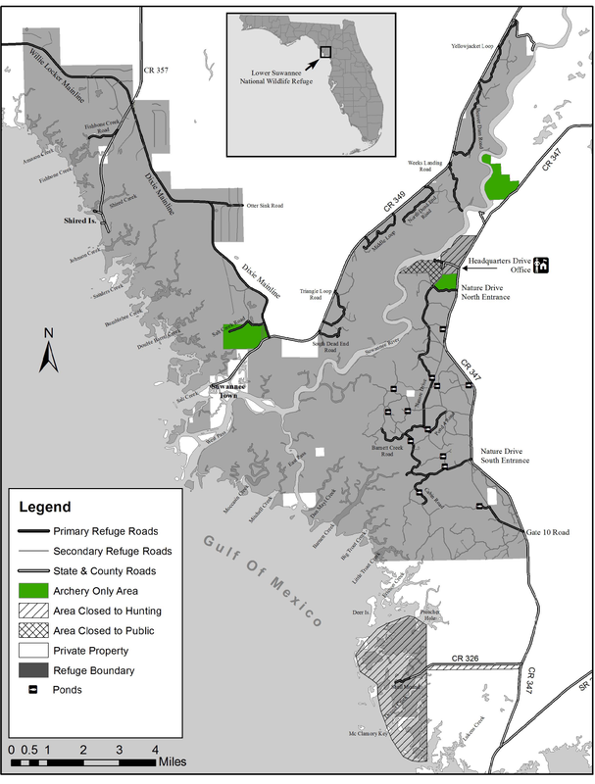
Lower Suwannee National Wildlife Refuge
16450 NW 31 Place Chiefland, FL 32626
352-493-0238 ext. 224 or call/text 850-527-8535
http://www.fws.gov/lowersuwannee/
Info: https://www.fws.gov/refuge/lower-suwannee
Info: https://www.friendsofrefuges.org/
Maps: https://www.friendsofrefuges.org/maps.html
U.S. Fish & Wildlife Service
1-800-344-WILD (9453)
July 2025

