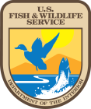
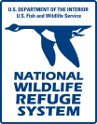
Edwin B. Forsythe National Wildlife Refuge
800 Great Creek Road, Oceanville NJ 08231
U.S. Fish and Wildlife Service
National Wildlife Refuge System

Hurricane Sandy Resilience Projects (#37)
Westecunk Creek (37a)
HQ Impoundment (37b)
Marsh Project (37c)

Edwin B. Forsythe
National Wildlife Refuge

Summary Report

November 2019

Virginia Rettig, Refuge Manager
Rich Albers, Deputy Refuge Manager
Paul Castelli, Wildlife Biologist
Vincent Turner, Wildlife Biologist
Amy Drohan, Fish and Wildlife Biologist

37a Westecunk Creek Project (F15PD00834)

Spending Plan Line Nos. 10 (design and permitting) and 20 (construction)

- The Westecunk barrier removal project was 100% complete in February 2016
- Post monitoring was conducted by cooperating partner Barnegat Bay Partnership (BBP) (Cooperative Agreement F15AC00016: Westecunk Creek Fish Monitoring) and is now complete.
- 13km of waterway opened to tidal flow; 0.15 acres restored
- There are no post-project action items.

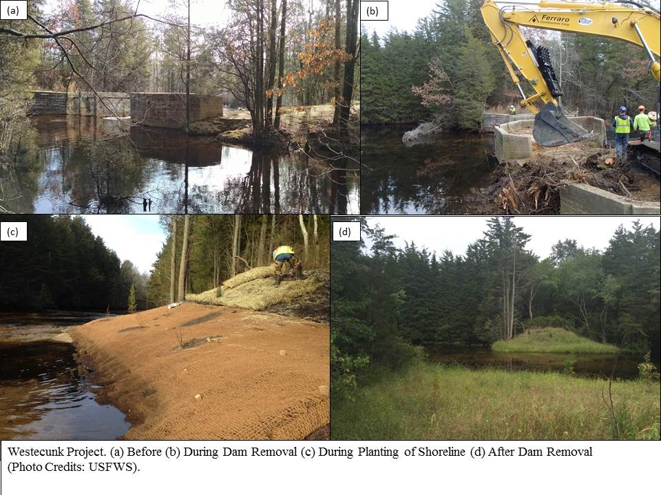

37b HQ Impoundment Project (F15PD00834)

Recovery Project Funds:
Designs and construction for armor (riprap) of Dogleg section of North Dike and Turtle Cove section of South Dike (Spending Plan Line Nos. 100-103)
- These Recovery-funded projects are 100% complete and were finished in winter 2017
- Post-construction action items:
  - Continue to monitor sites…Dogleg is in good shape….Early on Turtle Cove took a few years to vegetate which left the beach open to the public. It is starting to fill in.

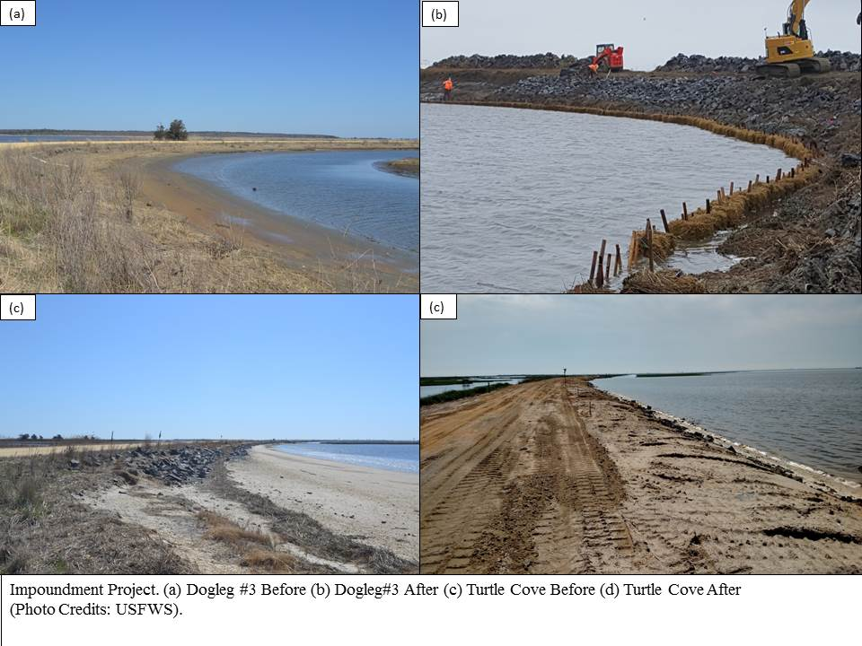

Resiliency Project Funds:

Water Balance study of the HQ Impoundment System (Spending Plan Line No. 200)
Design and Construction of Long Dike Repairs (Spending Plan Line Nos. 201 and 204)
Design for replacement and Construction of East Dike WCS #3 (Spending Plan Line Nos. 202 and 205)
Construction of Wildlife Drive re-surface (~ 6 miles) (Spending Plan Line No. 203)
- These Resiliency-funded projects are 100% complete and were finished in the winter of 2016 and early 2017
- WCS #3 improved water management for 570 acres (East Pool)
- Culvert installation in Long Dike and repair of that dike allowed water management in the West Pool (850 acres) for the first time in nearly 15 years
- Post-construction action items:
  - Some erosion (expected) along the Long Dike has occurred. We plan to place new sediment along the north side of the dike in weak areas to make a buffer for fetch that comes across this large impoundment
  - The pipe installed in Long Dike to move water between the 2 West Pools is undersized and filling with sediment, requiring more maintenance than planned. We are monitoring the situation and will keep the area maintained
  - We are meeting with partners to discuss future management options for the West and East Pools as we move toward a more resilient system
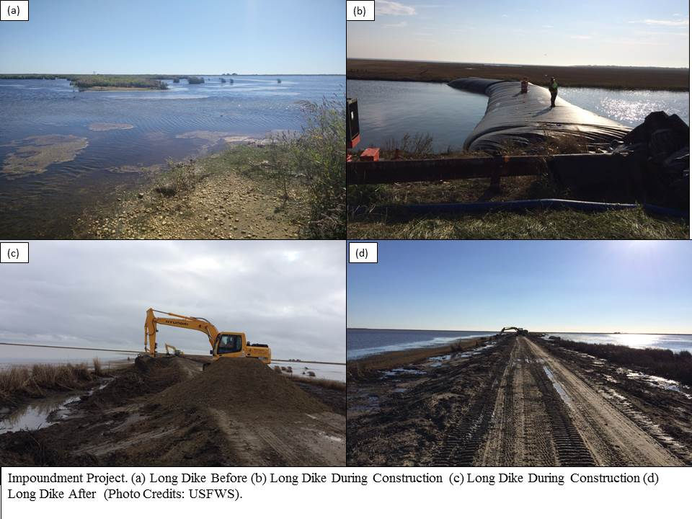
37c Marsh Enhancement and Telephone Removal (F15PD00834)

Pole removal and designs (Spending Plan Line No. 110 and 119)
- The pole project at Good Luck Point was completed the end of March 2017
Tidal flow restoration designs (Spending Plan Line No.101)
- The culvert at Good Luck Point was installed and completed in fall 2018
Sediment Enrichment (Spending Plan Line No. 100 and 101)
- Designs are complete and permits for 3 project sites are in hand. Two projects (A & B are in Brick Township. The third project would be at Good Luck Point.
- At this time, construction is likely best implemented with partner New Jersey Department of Transportation (NJDOT). We are seeking funding to construct the Good Luck Point project.

- Post-construction action items:
  - In the future, we hope to improve the access road in the pole removal area and open for public use
  - Tidal movement is occurring at Good Luck Point through Bayview Avenue. Refuge biologists are monitoring water levels with NFWF funds
  - Of the 3 permitted marsh enhancement projects, the refuge is working with NJDOT to seek NFWF funding for the Good Luck Point project. We are also developing other projects with NJDOT and other partners

